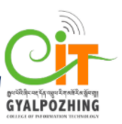

Proposal
For
Second Year Project
Bachelor of Science in Information Technology

Project Name: Bblogging.

Submitted by
Sonam Choki(12190078)

Gyalpozhing College of Information Technology

Read carefully before filling the form.

- Please do not alter the layout of the application form. Information must be filled in the spaces provided, under set format.
- Guidance notes in various fields should not be deleted.
- Required information should be duly filled in the specified fields.
- Required heads/fields which are not relevant to the project should be marked N/A (Not Applicable) or left blank and should not be deleted.
Guidelines and Forms

Submission Procedure
Duly filled proposal forms completed in all respects should be submitted in form of soft copy and a hard copy to project guide and project coordinator. On receipt of the applications the proposals will be evaluated by reviewer panel and proposal would then be defended by student groups. The project group may need to revise the proposal in light of the evaluator’s recommendations.

For further information, please contact:

Project Coordinator

Sonam Wangmo
sonamwangmo.gcit@rub.edu.bt
Table of Contents
Description Page #

1. Project Identification 1
2. Scope, Introduction and Background of the Project 3
3. Aim and Objectives of the Project 5
4. Methodology 6
5. Benefits of the Project (Expected output/outcomes): 10
6. Risk Analysis/Feasibility 10
7. Project Approval Certificate 11
8. Reviewers Panel Comments 13
10. Project Schedule / Milestone Chart /Work plan 14
13. Report Writing Guidelines 15
Bibliography 16

Note: To update the table of contents, right click in the table and select ‘update field’ and then select ‘Update Entire Table’.

Application for Project

1. Project Identification
- Reference Number:
(for office use only)
- Project Title: BBlogging
- Project Internal Guide:
Name: | Sonam Wangmo
Designation: | Lecturer(Module Tutor)
Organization: | GCIT
Mobile # : | 17715831 | Tel. # :
Email: | Sonamwangmo.gcit@rub.edu.bt
C1. Project External Guide:
Name: | NA
Designation:
Organization:
Mobile # : |  | Tel. # :
Email:
C2. Student Group Lead:
Name:
Roll No:
Department:
Mobile # : |  | Tel. # :
Email:

- Organizations Involved in the Project:
(Please identify all affiliated organizations collaborating in the project, and describe their role/contribution to the project.)
D1. Industrial Organizations:
# | Organization Name |  | Role / Contribution
 | NA
D2. Academic Organizations:
# | Organization Name | Role / Contribution
D3. Funding Organizations:
# | Organization Name |  | Role / Contribution
 | NA
- Key Words:
(Please provide a maximum of 5 key words that describe the project. The key words will be incorporated in our database.)
      - Images.
      - Publish
      - Videos
      - Notes.
      - Draft.
- Research and Development Theme:

BBlogging is social media platform where you can read, write and follow your favorite bloggers. And if you are a blogger you can gain more traffic on your blogs. It will serve as a platform where a writer or a group of writers can share their views on any individual subject, topics, knowledges, their thoughts and experiences regarding anything such as food, musics, places, education etc. Your audience will soon learn that you are providing useful, fun, unique content across various platforms, allowing them to engage however works best for them. Vivid pictures with informations and videos will keep the new bloggers or your audiences interested and engaged in the stuffs individual post. Moreover, it will also help people express themselves and share their passion, refine individuals writing skills and get more exposure to world outside them.
- Project Status:
(Please mark ☑)
q New ☑ Modification to previous Project
☑ Extension of existing project

- Project Duration:
Expected Starting Date: | 3th March,2021
Planned Duration in months: | 3 months.

2. Scope, Introduction and Background of the Project
- Scope of the Project:
- System Scope

To develop a mobile application with following features:
- Category selection.
- Images/videos.
- Firstly, the user and the bloggers need to sign up if they don’t have an account, but if they do, they can directly access by signing in with required email and password.
- The app will be designed in such a way that it will consist of the feature category which will include food, musics, places and education so that the users and the bloggers can post/view in any field they are interested to.
- For the bloggers, there will be options such as published and drafts.
- After posting the stuffs, there will be options such as edit, delete and share so that the bloggers can undo or make changes to the stuffs they have posted.
- The audience and the users can like, comment, share and follow the blog and the bloggers they find fun.

II) User Scope

The main scope of this project is mainly for the people in Bhutan so that they share any stuffs they are interested in this platform and get connected among themselves through posting/sharing online.

- Introduction (Project Background and Literature Review, Current State of the Art):

(Detailed summary of what all has been done internationally in the proposed area quoting references and bibliography. Please note that this section demonstrates the depth of knowledge of the project team and builds the confidence of the evaluators about capability of the team in achieving the stated objectives.)
(Please describe the current state of the art specific to this research topic.)
Project Background:

Today, due to the development of the world, there is no one who doesn’t have access to smart phones. All has become simple thanks to rapid advances in mobile technology. The mobile world is no longer confined to simple needs such as chatting and phone calls.
calls, and so on, but it has also launched smartphone apps that make people's lives simpler in any way possible. People can use a variety of smartphone applications to suit their needs and convenience at any time and in any place.

One of the interesting mobile application can be Blogging. Blogging refers to writing, photography, and other media that's self-published online. It started as an opportunity for individuals to write diary-style entries, but it has since been incorporated into websites for many businesses and other important purposes. There are even distinctions among types of blogs - business, lifestyle, fashion, food, and entertainment blogs, among others. While the blogging scene has developed over the last decade, the benefits of blogging are still plentiful.
A list of reasons why people blog and how blogging can benefit your personal or professional life includes :
- Express Yourself and Share Your Passions.
- Share Your Knowledge
- Refine Your Writing Skills
- Build Your Professional Network
- Earn More Exposure
Like wise, there are many other benefits and advantages of using blog/blogging. So by developing this application Bblogging, I want to make the people of Bhutan to utilize their time and knowledge in a proper way so that they can be benefited in all the ways that are mentioned above.

Literature Review:

Paper Review:

- Vlogging: A Survey of Videoblogging Technology on the Web :

When the Web was invented, practically all forms of online media were still very much
a one-way street. However, with the rapid development and proliferation of the World
Wide Web, particularly with the emergence of Web 2.0 [O’Reilly 2005] and beyond, we
now have new means by which to express our opinions and gain access to informa-
tion instantly. Weblogs (blogs for short) are playing an increasingly important role in
realizing this goal. Like instant messaging, email, cell phones, and Web pages, blogs
are a new form of mainstream personal communication, allowing millions of people
to publish and exchange knowledge/information, and to establish networks or build
relationships in the blog world [Rosenbloom 2004]. Blogs began as a textual genre
of personal publishing, but within this genre visual expression, such as photoblogs,
and the adaptation of sound and video [Hoem 2005] were developed. By combining
the ubiquitous, grassroots blogging with the richness of expression available in video,
videoblogs (vlogs for short) will be an important force in a future world of Web-based
journalism and a powerful new media adjunct to our existing televised news sources
[Parker and Pfeiffer 2005]

App Review:

- Blogger Plus : Blogger Plus allows the users to easily maintain full control of your pages. It is a beautifully designed app with the features such as Compose a post and save it as a draft or publish it right away, Edit previous posts, View a list of your saved and published posts, Switch accounts/blogs if you have more than one, Format and match text and Add multiple pictures to posts and pages.
You can easily and instantly publish posts to your blog using the Blogger Plus app, no matter where you are.

- Bloglt! : BlogIt! is a free Blogger application with a robust editor with following features: It allows users to edit their posts with a rich editor, Add several images/pictures to your posts , Quickly schedule when to publish, Fully Supported Offline Mode, If you need to make changes to your posts, you can use the HTML Editor, Check your Blog stats - View/Delete/Add Comments. It is a user friendly application.

- My Blog – New free Blogging App : MyBlog is a completely free blogging application where the Users can now conveniently build and post their own blogs, and the rest of the world will be able to read them. They can also Create fantastic blogs to be featured on the Explore list. This app serves as a platform to explore new things easily and effectively. Follow your favorite blogger so you don't miss any of their latest posts.

Current State of Art:
Currently, there are a lot of Blogging apps for the users/bloggers to use. However, unlike other countries, our country Bhutan being a small and under developed country in a lot of ways lacks in many things such as exposure, coming forward, to share and talk about our thoughts, experiences and so on. Even though, we want to share about these stuffs, we lack in a proper platform to connect and share those things. So by developing this app, I want to provide a better platform and aim to allow people of Bhutan to express themselves and share their passion, field of interests, refine their reading and writing skills and get more exposure to world outside them

.

- Challenges:
(Please describe the challenges, specific to this research topic, currently being faced internationally.)
- Security: when designing an application, security issues can be a nagging concern.

- Boosting the app’s visibility : After successfully creating and launching the mobile app, marketing and promotion of the applications is a noteworthy challenge.

- Performance : make the app responsive and smooth.
- Motivation and Need:
(Please describe the motivation and need for this work.)
Internet has become very essential in our daily life, use of internet has increased enormously in every vicinity and also escalating every year. Blog has become one of the primary and valuable parts of this phenomenon. Blogging has rapidly become one of the trendiest ways of communicating and spreading information and news. There are factually million of blogs online and numbers are increasing regularly and so is the demand for blogs are also mounting. So by developing this app, I want to create a platform for the people to share their thoughts and knowledges online and also because the process of writing helps you think, the content you create can promote your brand and expertise, so a blog is a great way to stay in touch with people and meet new people.

3. Aim and Objectives of the Project
(Please write the actual aim of your project. Also, describe the measurable objectives of the project and define the expected results. Use results-oriented wording with verbs such as ‘to develop..’, ‘to implement..’, ‘to research..’, ‘to determine..‘, ‘to identify..’ The objectives should not be statements and should not include explanations and benefits. The objective should actually specify in simple words what the project team intends to achieve (something concrete and measurable/ deliverable). Fill only those objectives that are applicable to the proposed project.)
AIM : To allow people of Bhutan to express themselves and share their passion, refine individuals writing skills and get more exposure to world outside them.

OBJECTIVES : The main objective of this development are:
- To let people share and express their thoughts and ideas.
- To enable people to gain knowledge out of their bound/learn new things.
- To develop an android application which serves as a platform where the individuals can read, write and follow your favorite bloggers

4. Methodology

- Development / Research / Test Methodology:
(Please describe the technical details and justification of your development and research plan and test plan and testing strategies. Identify specialized equipment, facilities and infrastructure which are required for the project and their utilization plan. The block diagrams, system flow charts, high level algorithm details etc. have to be provided in this section. Also, describe the overall methodology to be used for the particular research topic)

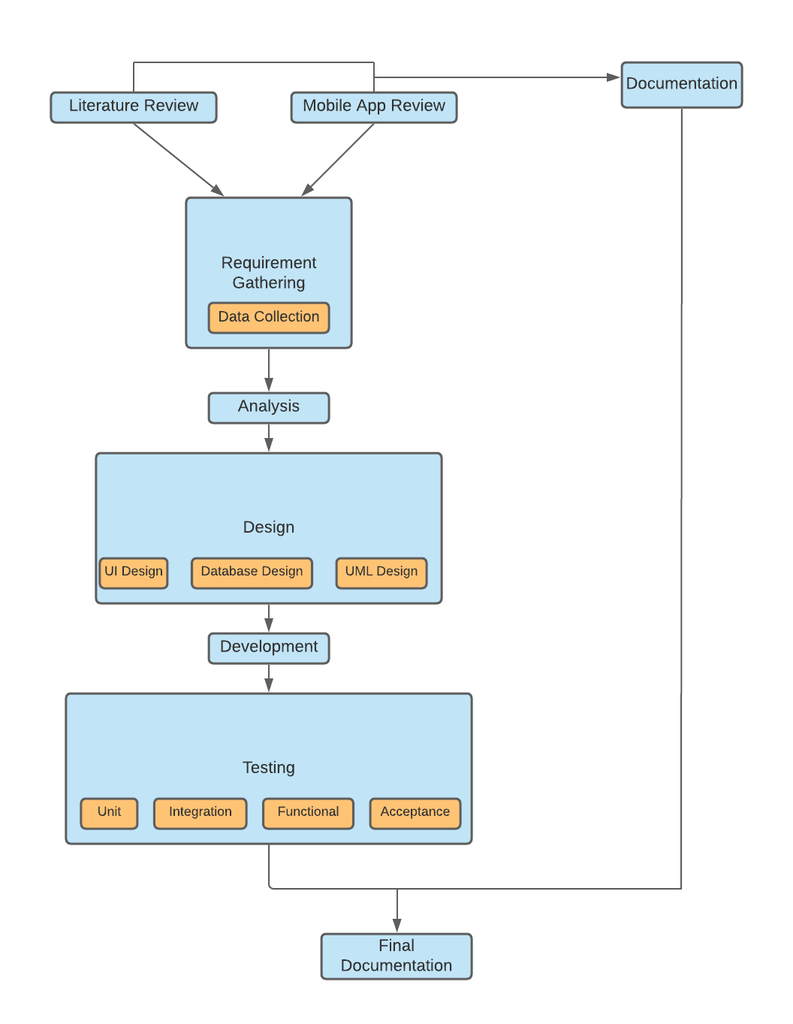
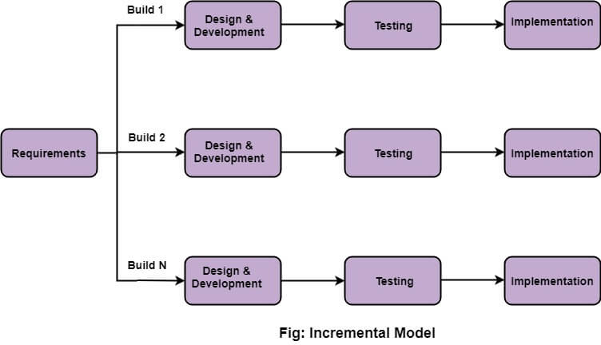

An iterative life cycle model does not start with a full specification of requirements. In this model, the development begins by specifying and implementing just part of the software, which is then reviewed in order to identify further requirements. Moreover, in iterative model, the iterative process starts with a simple implementation of a small set of the software requirements, which iteratively enhances the evolving versions until the complete system is implemented and ready to be deployed. Each release of Iterative Model is developed in a specific and fixed time period, which is called iteration. Furthermore, this iteration focuses on a certain set of requirements. Each cycle ends with a usable system i.e., a particular iteration results in an executable release. Iterative Model allows accessing previous phases, in which the changes are made accordingly. The final output of the product is revived at the end of the Software Development Life Cycle (SDLC).

Reason to select this model: Generates working software quickly and early during the software life cycle. It is easily adaptable to the ever changing needs of the project as well as the client. It is more cost effective to change the scope or requirements in Iterative model. Testing and debugging during smaller iteration is easy. Risks are identified and resolved during iteration; and each iteration is an easily managed. In iterative model less time is spent on documenting and more time is given for designing.

- Project Activities:
(Please list and describe the main project activities, including those associated with the transfer of the research results to customers/beneficiaries. The timing and duration of research activities are to be shown in the Gantt chart in Section 8.)
- Feasibility Study: Through review on the different papers and mobile app.
Installation of software and tools: Installing android studio version (2 and above),
Java Development Kit (v8 or more) , database server and Visual Studio Code.

- Resource gathering: Android app-related books, guides, videos, and online references XML and growth.

- Design Phase : Designing the user interface, database develop, and familiarizing yourself with the system's functionalities, which would provide an understanding of how the control flows while keeping the design principles in mind.

- Development of the product: The development of app begins here with coding using android.

- Testing the product: The product will go through unit testing to ensure that each unit operates correctly, as well as integration testing to ensure that when all of the units are integrated, it achieves the desired result. In addition, if any bugs are found, we will fix the issues and perform additional checks to ensure that the application works properly.

- Final Documentation: After all the phases are done we will prepare the
documentation of the project, project report and finally conclude with the final
presentation.

- Key Milestones and Deliverables:
(Please list and describe the principal milestones and associated deliverables of the project. A key milestone is reached when a significant phase in the project is concluded, e.g. selection and simulation of algorithms, completion of architectural design and design documents, commissioning of equipment, completion of test, etc.) The timing of milestones is also to be shown in the Gantt chart in Section 8.
No. | Elapsed time from start (in months) of the project | Milestone | Deliverables
1. | 3/03/2021 –14/03/2021 | Title selection, problem statements, brainstorming, literature review and Conduct survey(Analysis) | Project proposal report and  presentation
2. | 15/03/2021 – 02/04/2021 | Requirement gathering,  analysis and design. | SRS document, ER diagram, Relational diagram, architecture design, database design, User  interface design.
3. | 03/04/2021 – 06/04/2021 | Software installation | Setting environment for  development
4. | 07/04/2021 – 08/05/2021 | Development/ coding | Source code and functional  features implemented
5. | 09/05/2021 - 16/05/2021 | Testing | Test case
6. | 17/05/2021 -23/05/2021 | Complete development and  testing | Complete android app
7. | 24/05/2021 – 28/05/2021 | Final Documentation | All document combined  together and ready
(Please add more rows if required.)

5. Benefits of the Project (Expected output/outcomes):
The benefits from the project are:
1. Make people get more exposure and learn new things.
2. To refine one’s reading and writing abilities.
3. Make good connections among people through sharing and posting online.
4. Keeps people updated.

6. Risk Analysis/Feasibility
- Risks of the Project:
(Please describe the factors that may cause delays in, or prevent implementation of, the project as proposed above; estimate the degree of risk.)
(Please mark ☑ where applicable) Low Medium High
Technical risk  ☑ 
Timing risk  ☑ 
Budget risk ☑  

A1. Comments(Describe the risk):
Technical risk : It's likely that a technological problem could occur, such as file corruption or an OS crash.

Timing risk: Since we need time to learn and develop Android production, conducting research, and developing the app's content, so it will be little difficult for us.

Budget risk: We don't have to buy any software or technology, so there's no budget risk. Our project can be completed with free software found on the internet.

7. Project Approval Certificate
(Approval of Project Proposal by the Competent Authority (Department Chairman) and Project Review Team is mandatory before the start of project execution.)
Project Review Team:

Sl # Name Signature

(Please add more rows if required.)

Project Coordinator
Name:
Designation:
Email:
Date: Signature:

Competent Authority – Head of Department
Name:
Designation:
Email:
Date: Signature
& stamp:

10. Project Schedule / Milestone Chart /Work plan

(Project schedule using MS-Project (or similar tools) with all tasks, deliverables, milestones, clearly indicated are preferred. Task should be measured in terms of hours)

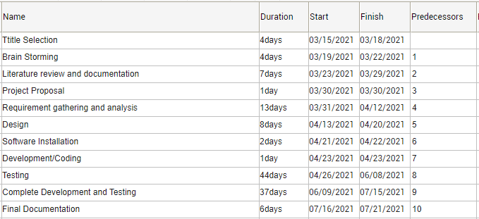

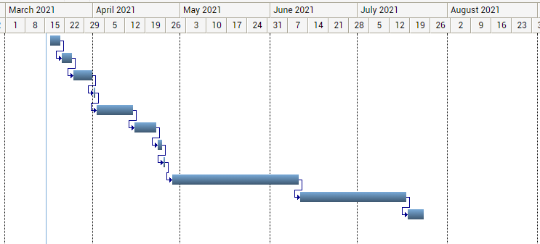

13. Report Writing Guidelines

(Project report will be written under the specified guidelines.)

Bibliography
- Blogger plus - apps on Google Play. (n.d.). Retrieved March 13, 2021, from https://play.google.com/store/apps/details?id=dev.jideguru.bloggerPlus.android&hl=en

- Blogit! (blogger) - apps on google play. (n.d.). Retrieved March 13, 2021, from https://play.google.com/store/apps/details?id=com.jcorreia.blogit&hl=en

- Dekmezian, G. (2016, September 23). Why do people blog? The benefits of blogging. Retrieved March 13, 2021, from https://www.huffpost.com/entry/why-do-people-blog-the-be_b_8178624

- Gao, W., Tian, Y., Huang, T., & Yang, Q. (2010). Vlogging: A survey of videoblogging technology on the web. ACM Computing Surveys (CSUR), 42(4), 1-57.

- MyBlog - new free blogging app - apps on Google Play. (n.d.). Retrieved March 13, 2021, from https://play.google.com/store/apps/details?id=com.rahulgaur.myblog&hl=en

